TECHNICAL DATA SHEET

Product Name: Disposable Single Use C-Section Pack
Item No: CS-STP0001
Classification: A
Description: Majority components are made of SMMS,by cutting, punching and processing with certain protective characteristics, including 7 accessories: table cover, Mayo stand cover, reinforced surgical gown, C-section drape, baby drape, etc.
Intended Use: Clinical surgery in relevant departments of medical institutions.
Material: 65gsm absorbent PP+PE+PP
Graceheal Medic Sdn. Bhd
Manufacturer /
Assembler:

Country of Origin: China / Malaysia
Specification:
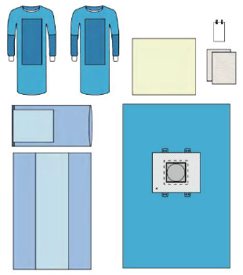

Component | Description | Material | Color | Quantity
Table Cover | 140x190cm (60x190cm) | PP + PE | Blue | 1
Mayo Stand Cover | 76x145cm (48x60cm) | PP + PE | Blue | 1
Surgical Gown | XL 130x150cm | SMMS | Blue | 2
C-Section Drape | 220x300cm, with: Fenestration 30x30cm,  adhesive, liquid collection pouch 75x75cm,  tube holders | PE+PP+PP | Blue | 1
BABY Drape | 90x80cm | Spunlace | White | 1
Hand Towel | 30x40cm | Paper | White | 2
Suture Bag | 17x30cm | Paper | White | 1

Packaging:
1) Carton Requirements: Single layer
2) Packing Quantity: 1 set /header pouch, 6 set /ctn

Storage：
1) Store in dry, clean conditions in original packaging.
2) Avoid direct sunlight, high temperature or humidity.
3) Storage temperature ranging from -5℃ to +45℃ and with relative humidity below 80%.

Shelf Life：
36 months from the date of manufacture when stored as stated above.

Cautions and disposal：
1) Do not contact with heavy oils, sparks or flames.
2) Do not use in the environment with conditions of excessive heat.
3) Do not use if damaged, heavily contaminated or in accordance with local practice.
4) Dispose the contaminated products with care and in accordance with national regulations.
