TECHNICAL DATA SHEET

Product Name: Disposable Single Use Delivery Surgical Pack
Item No: DL-STP0001
Classification: A
Description: Majority components are made of absorbent PP+PE by cutting, punching and processing, including 10 kinds of accessories: table cover, Mayo stand cover, reinforced gown, delivery drape, baby drape, etc
Material: 55gsm absorbent PP+PE+PP
Manufacturer /
Graceheal Medic Sdn. Bhd
Assembler:

Country of Origin: China / Malaysia
Specification:

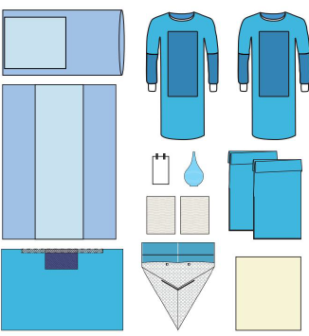

Component | Description | Material | Color | Quantity
Table Cover | 140x190cm (60x190cm) | PP + PE | Blue | 1
Mayo Stand Cover | 76x145cm (48x60cm) | PP + PE | Blue | 1
Reinforced Surgical Gown | XL 130x150cm | SMMS | Blue | 2
Reinforced Side Drape | 100x150cm(25x40cm), with  adhesive | SMMS | Blue | 1
Under buttock drape | 86x108cm,with liquid collection  pouch | PP + PE | Blue | 1
Legging | 80x120cm | SMMS | Blue | 2
Suture Bag | 17x30cm | Paper | White | 1
Baby Drape | 90 x 80cm | Spunlace | White | 1
Hand Towel | 30x40cm | Paper | White | 2
Bulb Syringe | - |  | Blue | 1

Packaging:
1) Carton Requirements: Single layer
2) Packing Quantity: 1 set /header pouch, 10 set /ctn

Storage：
1) Store in dry, clean conditions in original packaging.
2) Avoid direct sunlight, high temperature or humidity.
3) Storage temperature ranging from -5℃ to +45℃ and with relative humidity below 80%.

Shelf Life：
36 months from the date of manufacture when stored as stated above.

Cautions and disposal：
1) Do not contact with heavy oils, sparks or flames.
2) Do not use in the environment with conditions of excessive heat.
3) Do not use if damaged, heavily contaminated or in accordance with local practice.
4) Dispose the contaminated products with care and in accordance with national regulations.
