TECHNICAL DATA SHEET

Product Name: Disposable Single Use Laparotomy Pack
Classification: A
Description: Majority components are made of SMMS by cutting, punching and processing with certain protective characteristics, including 6 accessories: table cover, Mayo stand cover, reinforced surgical gown, laparotomy drape, etc.
Intended Use: Clinical surgery in relevant departments of medical institutions.
Material: 45gsm AS-only SMMS
Graceheal Medic Sdn. Bhd
Manufacturer /
Assembler:

Country of Origin: China / Malaysia
Specification:
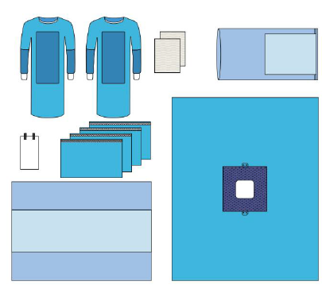

Component | Description | Material | Color | Quantity
Table Cover | 140x190cm (60x190cm) | PP + PE | Blue | 1
Mayo Stand Cover | 76x145cm (48x60cm) | PP + PE | Blue | 1
Surgical Gown | XL 130x150cm | SMMS | Blue | 2
Suture Bag | 17x30cm | Paper | White | 1
Hand Towel | 30x40cm | Paper | White | 2
Laparotomy Drape | 200x250cm, with: fenestration 25x25cm,  reinforce area 60x60cm(100gsm SM/PE  pad), adhesive, tube holders | SMMS | Blue | 1
Side Drape | 38x66cm, with tape | SMMS | Blue | 4

Packaging:
1) Carton Requirements: Single layer
2) Packing Quantity: 1 set /header pouch, 10 set /ctn
Storage：
1) Store in dry, clean conditions in original packaging.
2) Avoid direct sunlight, high temperature or humidity.
3) Storage temperature ranging from -5℃ to +45℃ and with relative humidity below 80%.
Shelf Life：
36 months from the date of manufacture when stored as stated above.
Cautions and disposal：
1) Do not contact with heavy oils, sparks or flames.
2) Do not use in the environment with conditions of excessive heat.
3) Do not use if damaged, heavily contaminated or in accordance with local practice.
4) Dispose the contaminated products with care and in accordance with national regulations.
